
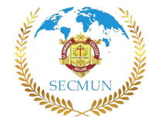
secmun2024@gmail.com
Est. 2014
St. Edmund’s College Model United Nations Club

9th April 2025

To,
The Principal
St. Edmund’s College

Subject: Invitation to the opening & closing ceremony of Intra-SECMUN Conference 2025

Respected Brother,

We are pleased to invite you to the opening & closing ceremony of Intra-SECMUN Conference 2025 on April 11th & 12th in AV Room 2. This year’s theme, "Represent, Report, Rise," focuses on diplomacy, journalism, and public discourse. In this regard we would like to humbly request you to address the gathering with your insightful words on the opening ceremony.

Your presence would be an encouragement to the participants as they engage in discussions and policy debates. We would be honoured to have you as our guest.

Kindly find attached herewith the program schedule of the opening and closing ceremony for your kind reference.

Hoping for your kind consideration of our invite.

Warm regards,
SECMUN Secretariat
Bhushan Kalita  President  70996 13601 | Vivian A L Nonglait  Secretary General  87876 97831 | Naphibansabet Byrsat  Director General  93662 61701

